Nguồn :
- https://www.tomtom.com/traffic-index/new-delhi-traffic/
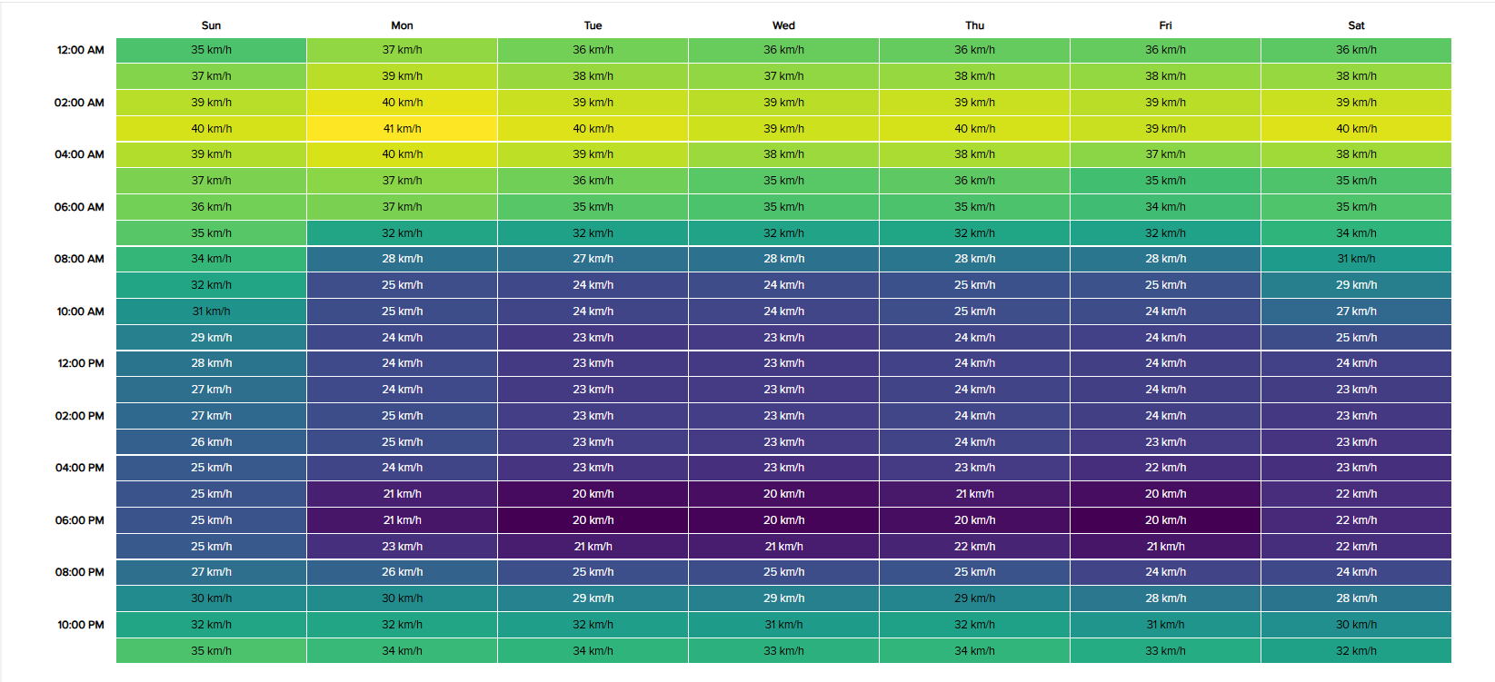
- https://essd.copernicus.org/articles/15/661/2023/
